Change of Principal Amount Waived
SUKUK PRIHATIN - CHANGE REQUEST FORM | 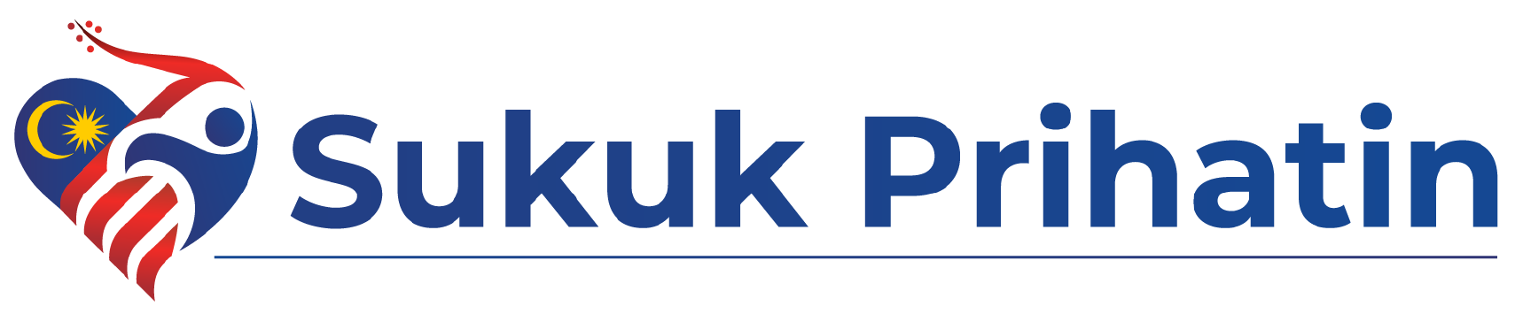
Kindly complete & email this change request form to:
Helpdesk: [Distribution Bank to insert number] Email: [Distribution Bank to insert email address]
Date of Request: |  | Channel:
Distribution Bank:

Details of Investor

Reference No:  (per Statement) |  | Investor’s Name:  (per NRIC)
Email Address registered |  | NRIC:
Registered Contact Number |  | Business Registration No:  (if applicable)
Account Number

Details of Donation Change Request

Amount Invested/Principal Amount Waived during application: | RM ____________________(A)
New Principal Amount Waived | RM ____________________(B)
Final Principal to be credited to Account | RM ____________________(A-B)

For Distribution Bank use only

Bank
Verification by |  | Date
Name |  | Department
Contact Number |  | Email

Declaration by Distribution Bank
- We confirm we have performed the necessary verification on the customer/investor.
- We confirm all information provided above are correct and in order.
For Maybank use only
Signature Verified by: |  | Request Authorized by:
Name of Officer: |  | Name of Officer:
Date: |  | Date:
Contact Number: |  | Contact Number:
Email: |  | Email:

